Name:  Class: | ____________________________________  ________________ |  | Date:_________
 | Year 11 Foundations Mathematics  /47  5 %  Test 2 2018
Total Time: | 55 minutes
Weighting: | 5%
Equipment: | To be provided by the student: Pen, pencil, ruler,1 double sided A4 page of notes, scientific calculator
[ 5 marks ]
- List five key features of clear bar and column graphs.

[ 1, 1: 2 marks ]
- The graph shows the typical midday and night time (2 am) temperatures at Exmouth.

Typical Midday and Night Temperatures at Exmouth
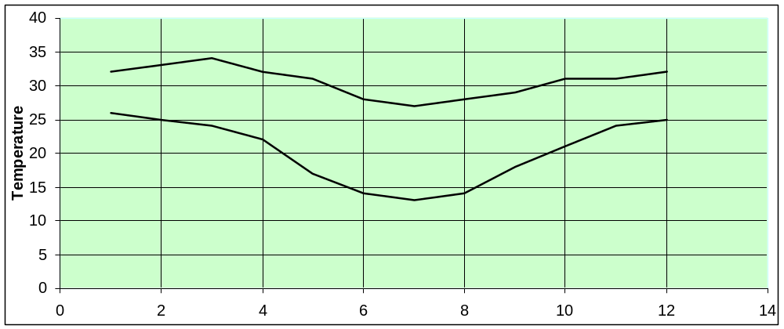

Midday

  - Which key feature of line graphs is missing from the graph?

  - Someone reading this graph states that the typical midday temperature in Exmouth is always over 30 degrees. Is this statement correct?

[ 1, 1, 1, 2: 5 marks]
- This table shows how students in senior school travelled to school yesterday.
Means of travel to school | Number of students
Train | 8
Walk | 20
Car | 7
Moped | 3
Bike | 6
Bus | 16
TOTAL
  - Complete the table above with the total number of senior school students.
  - How many of the students walked to school?

  - How many of the students travelled by moped?

  - How many of the students didn’t travel by train?

[ 1, 1, 1, 1, 2: 6 marks]

- The Two way table shows the numbers of people in a group who use emails and/or internet banking.

 | Email | No Email | Total
Banking | 12 | 2 | 14
No Banking | 6 | 11 | 17
Total | 18 | 13 | 31

  - How many people are in the group?

  - How many people in the group don’t use either internet banking or email?

  - How many of the group use both email and internet banking?

  - Calculate the number of people who use email.

  - Does the information support the statement that most people who use internet banking also
use email? Use values to support your answer.

- A fair die is rolled 60 times resulting in the following: [ 4, 5: 9 marks ]
4, 6, 1, 5, 4, 6, 2, 3, 3, 1, 3, 5, 4, 1, 6
5, 6, 3, 4, 5, 2, 6, 4, 5, 2, 2, 4, 1, 1, 4
3, 6, 2, 3, 4, 1, 3, 5, 2, 3, 2, 5, 3, 1, 6
2, 5, 4, 4, 6, 3, 1, 1, 5, 2, 5, 1, 5, 2, 1
  - Complete a frequency table for this data.
Number on Die | Tally | Frequency
 | Total

  - Construct a column graph to show this information.

  - Could you use another graph to display this information? If so, which graph would you choose?

- Sam works at a Gelato shops and records the number of people buying ice-creams in a 1 hour period. He says that the most popular flavor is Plain Jane vanilla. Help him prove his point by select the correct graph to display this data and construct that graph below: [5,6; 11 marks ]
 | Nutella | Triple choc | Berry Swirl | Plain Jane
Males | 4 | 10 | 9 | 16
Females | 15 | 12 | 8 | 6

  - Of the flavours Sam has, which was most popular overall? How can you tell?

  - Which flavor was the most different between boys and girls?

  - Was Sam correct in his statement?

- Sophie says to Skye “most people that have iPhone also have a mac”. They surveyed all students in year 11 and got the following results. 62 have both, 14 have neither. 118 have iPhone and 80 have a mac. [4,2,3; 9 marks]

  - Construct a two way table to represent this data.

  - How many people had a Mac, but no iPhone?

  - Skye says that there is 118 iPhone and 80 MacBook’s, which means that there is 198 people with either an iPhone or a mac. Is she correct or not? Why?

